# Remote Diagnosis

* Errorhandling.mjs

In Error handling file, the custom class of error is made with js.

* InfluxSetup.mjs

In influxdb setup file, we are exporting the influxdb class with token and url of influxdb for storing the data, and we are also exporting the writeApi variable for writing onto the influxdb database using the influxdb class.

* Validateandformat.mjs

In validateandformat file, the measurements and default_pic with default values and tzoffset to correct the timezone.

In Function groupBy(arr, b), arr is array of the values of the variable, b is used to place value of the array that is currently on.

In Function grpByTen(arr), array of the values of the variable and grouping It by the ten places.

In Function validateAndFormat(data), the data is checked for the all values like pic_id, time, date, vdc, idc, idref, rpm, tmot, tesc are present or not. And In first loop, timeValue is added with tzoffset to get the correct value of the time with date in epochD and data is grouped into the ten for the value is because the we storing the value of data per millisecond(0-9). In second loop, now we are storing the values onto the influxdb database according to the timestamp.

* deleteHandle.mjs

In function deletedata(id), id used to deleted the specific measurement and we are using the class DeleteApi from influxdb_client-api and then we postDelete inbuilt function to delete the predicate, start (specific range) and stop(specific range) then we return the true or false according the data is deleted or not.

* Index.mjs

The main file of the all the operation are going to perform on the api we are using logger variable for storing the LokiTransport values and have two router.

In Clear Router, request is taken in request query as id. It is used to delete the data from influxdb.

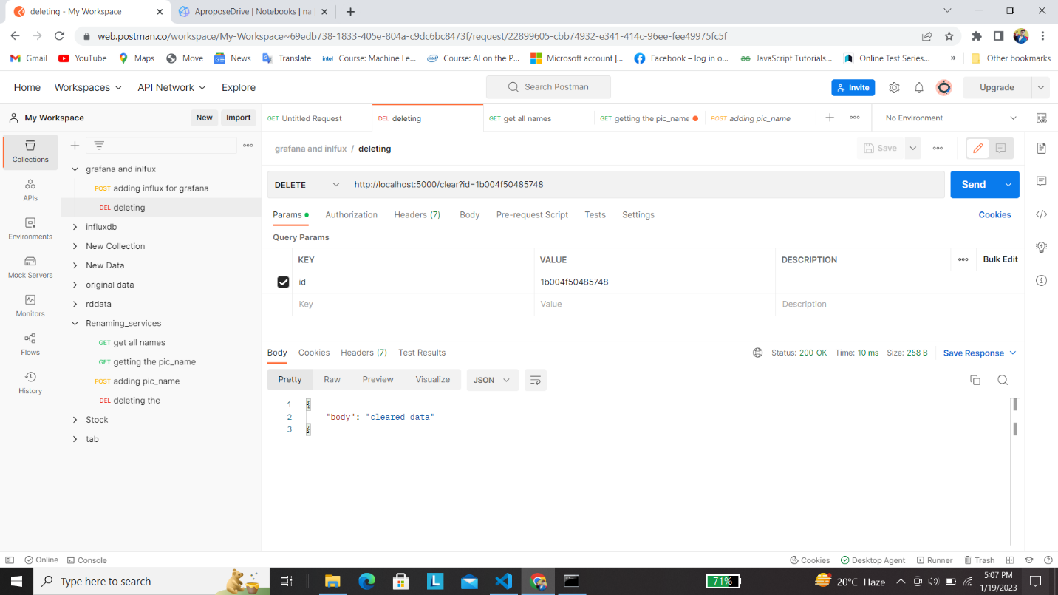

In Add Router, data is given in json format in body with pic_id and give back how many data is added onto the database in response. Example for json: { “pic”: “name”, “date”: [], “time”: [], “var0”:[], “var1”: [], “var2”: [], “var3”:[], “var4”:[], “var5”:[], “var6”:[],”var7”:[], “var8”: [], “var9”:[], “var10”:[], “var11”:[], “var12”:[], “var13”: [], “var14”:[], “var15”:[], “var16”: [], “var17”: [], “var18”:[], “var19”:[] }

